BHAVAN'S B.P. VIDYA MANDIR, CIVIL LINES, NAGPUR-01.
BOARD RESULT STD -XII AISSCE 2023
Holding aloft the flag, of victory high, the students of Bhavan's Bhagwandas Purohit Vidya Mandir, Civil Lines, Nagpur brought extraordinary results in the AISSCE 2023.
Out of the 66 students who appeared for Science, 12 scored 90% and above.
In the Commerce Stream, out of the 49 who appeared, 16 students scored 90% and above.

- 45 students have secured Al grade in English,
- 19 in Physics,
- 21 in Chemistry,
- 14 in Mathematics, ,
- 07 in Engineering Graphics,
- 08 in Computer Science,
- 06 in Biology,
- 02 in Psychology,
- 27 in Economics,
- 20 in Accountancy,
- 13 in Business Studies
- 08 in Physical Education.

Toppers of Science Stream include :
- Ankush Shandilya 97%
- Ananya Kothari 95.4%
- Vanshaj Assudani 94.6%.

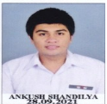 | 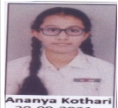 | 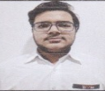

Subject wise toppers: Science Stream:

English (96) | Ankush Shandilya
Maths (97) | Ankush Shandilya
Physics (96) | Ankush Shandilya
Chemistry (99) | Ankush Shandilya
Biology (95) | Cherry Hazare  Pankhudi Singh  Ananya Kothari  Vidhi Sahare
Engineering Graphics (99) | Aastha Charde  Spandan Nath  Aditi Kumari
Computer Science (99) | Kaushik Shahu
Physical Education (91) | Esha Shahare
Psychology (98) | Ananya Kothari

COMMERCE STREAM:
Toppers of Commerce Stream –
- Mahita Gupta emerged topper with 97.6%,
- Ashlesha Guhe with 96.4%
- Manya Agrawal with 95.6%.

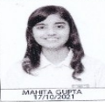 | 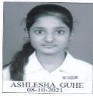 | 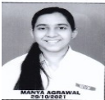

Subject wise toppers:
English (97) | Mahita Gupta
Economics (100) | Pratyush Gandhi  Aaradhya Lanjewar
Business Studies (99) | Mahita Gupta
Accountancy (100) | Chaitanya Panpaliya
Mathematics (99) | Mahita Gupta
Physical Education(98) | Hardik Garg  Soham Agrawal

The excellent performance is the culmination of the consistent effort, dedication, devotion and team work of Principal Smt. Anju Bhutani, faculty members and parents.
Principal Smt. Anju Bhutani congratulated all the students on their stupendous results.

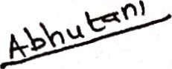

(SMT. ANJU BHUTANI)

PRINCIPAL
BHAVANS BHAGWANDAS PUROHIT VIDYA MANDIR
CIVIL LINES, NAGPUR 01
